Michigan Tech
MEEM 5250: Internal Combustion Engines II
Assignment 1

Units and Equation Solving

Instructor: Dr. J.Naber
Office: MEEM 1011
Email: jnaber@mtu.edu
Tel: 906.487.1938

Date Assigned: September 4, 2013

Date Due: September 13, 2011 11:00 AM

Instructions: This is an individual HW assignment to be turned in at the beginning of class (paper copy for on-campus students) and into Canvas (electronic copy for both on-campus and distance learning students).

Overview: As engineers, we communicate through graphs and figures. In reports, manuscripts and presentations these need to be introduced and discussed in order for effective communication. This exercise examines the discharge characteristics as they occur in a spark-ignited (SI) engine and compares data to existing correlations, and then utilizes a simple first law assumption to determine the plasma mass and temperature with comparisons to results presented by Heywood.

Assignment: Complete the sections as indicated by the lettered sections (A, B, …) and their respective subsections. Use the same organization and nomenclature in your assignment report
(see below for format of the report).

We will use this for discussion in class so please review the assignment and be prepared for questions in-class on Friday September 6, 2013.

Results and Analysis:

In recent data collected at the AERB at MTU in an electrostatic discharge research program, we measured the data in Table 1.
Table 1. Breakdown voltage measured at ambient conditions (25°C)
in low temperature ignition experiment with tungsten
electrodes as a function of electrode gap (d_{g}).

d_{g}  (mm) | V_{BD}  (kV)
1.5 | 5.86
1.5 | 6.60
2.4 | 7.40
3.1 | 8.56
2.4 | 7.24
2.4 | 6.76
2.4 | 6.72
2.4 | 7.14
2.4 | 7.78
2.4 | 6.90
1.5 | 6.60
1.5 | 6.36

This data can be compared to three correlations for the breakdown voltage.
- The rule of thumb for electrostatic discharge is:

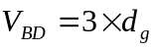, [2]
where
d_{g} = gap length [mm]
V_{BD} = breakdown voltage [kV].

- An alternative is given by Pashen’s law:

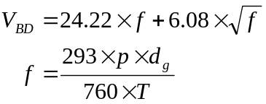, [2]
where
p = pressure [Torr]
T = temperature [K]
d_{g} = gap length [cm]
V_{BD} = breakdown voltage [kV]

- Alternatively in engine studies Pashely et al. found the relationship as follows.
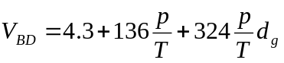, [3]
where
p = pressure [bar]
T = temperature [K]
d_{g} = gap length [mm]
V_{BD} = breakdown voltage [kV]

Complete the following and put in the assignment report.

Introduction: A paragraph summarizing the assignment.

Data Visualization, Plotting and Fitting (Utilizing Mathworks Matlab)
- Generate a figure comparing the independent variable from the experimental data to the correlations. Follow guidelines for plotting provided in supplemental material. Include the listing of the Matlab code in Appendix A.
- In a paragraph above the figure introduce and describe the figure and data as if it were in a report or published journal article.
  - Introduce and reference the figure number,
  - Explain what is plotted,
  - Describe the data and trends in quantitative terms – do not use qualitative adjectives (small, large, …),
  - Highlight and describe quantitatively one or more key observations in the plot.
- Examine the data and propose an appropriate correlation for the data. Plot the correlation with the data in a new figure (Figure 2) and discuss the figure as in part 2a-d.

Basic Engine Analysis (Utilize EES)
You are working to determine the ignition system requirements for a 3.5L Ford EcoBoost engine with the characteristics given in Table 2.
Table 2. Ford 2011 EcoBoost Engine Characteristics
Parameter | Value
Cylinders (#) | 6
Bore (mm) | 92.5
Stroke (mm) | 86.7
Connecting Rod Length (mm) | 152.7
Compression Ratio (#) | 10:1
Displacement (L) | 3.5
Maximum Torque @ 2500 rpm (lbf-ft) | 420
Maximum Horsepower @ 5500 rpm (hp) | 365
Maximum Boost (psig) | 14.5
Max BMEP (bar) | ??

- Complete the table above and convert all to SI units and include in the report.
- Complete the table below. In the write-up develop and give all equations used and give assumptions. For conditions at ignition assume polytropic compression with n = 1.32. Include a listing of the EES code in Appendix B.
- Discuss results in the table
  - Reference and introduce the table
  - Explain what is in the table
  - Describe the data and trends in quantitative terms – do not use qualitative adjectives (small, large, …),
  - Highlight and describe quantitatively one or more key observations in the table.
  - Compare results to that given in Figure 1. Draw a conclusion about the 0.6 and 1.4 mm gaps in comparison to this figure.
Table 3. Operational range of the engine for ignition requirements.
Engine  Speed | Engine  MAP | Ignition  Timing | P_{Ign} | T_{Ign} | Ignition  Gap | Ignition  V_{BD} | Ignition  BD and Arc  Energy
(rpm) | (kPaa) | (°BTDC) | (bar) | (K) | (mm) | (kV) | (mJ)
700 | 40 | 50 | 1.96 | 438.3 | 0.6 | 5.78 | 334.2
700 | 40 | 50 | 1.96 | 438.3 | 1.4 | 17.58 | 3092.0
2500 | 200 | 25 | 23.63 | 587.7 | 0.6 | 6.94 | 482.0
2500 | 200 | 15 | 32.88 | 636.7 | 1.4 | 34.71 | 12070.0

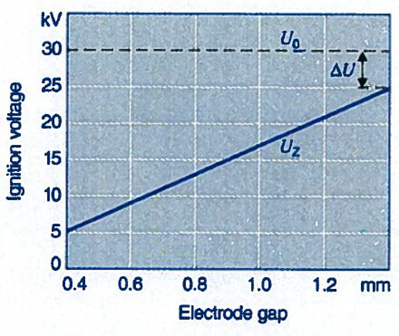
Figure 1. Required ignition voltage for breakdown [Bosch 2004].

First Law Analysis (Utilize EES)
From visualization studies (see Zhang et al. 2013) it can be estimated that the initial spark kernel immediately after arc has a diameter of 1.5 times the gap. Estimate the temperature of the kernel at this time for the 2500 rpm, 200 kPaa, 25°BTDC condition.
- Diagram the system including energy terms with the appropriate control volume(s).
- Write the first law for the control volume (format in report as an a numbered equation based upon examples above)
  - Give a table of unknowns and knowns following the nomenclature
in your control volume diagram.
  - Apply additional constitutive equations as needed to close the solution
(format as equation(s)).
  - Solve with the following assumptions (Include EES code listing in Appendix C).
    - Gas in the kernel behaves as an ideal gas with properties of air.
    - Neglect the energy release from the combustion of the fuel.
    - Assume a 90% transfer efficiency of electrical energy
to the gases in the kernel.
    - Process occurs nearly instantaneously at constant pressure without additional heat losses.
    - List any further assumptions you must make.
- Discuss above and compare to Figure 9.42 in Heywood.

Summary and Conclusions (1 Paragraph)
Format for Submission of Assignment
This is to be in the report format with the following sections. Submit to Canvas by the date and time indicated on the title page.
I. Cover sheet
Assignment title and number
Name
Date
Portrait picture.
II. Introduction, Results and discussions including all tables, figures, etc.
(per outline above A-D)
IV. Summary and Conclusions (part E)
Appendix: Codes and calculations and or other documentation/explanation of work
Include your last name and page number at the bottom of the page in the footer
Grade Sheet

Student: ___________________________________

Area | Points | Score
Cover Sheet | 5
- Introduction | 5
- Data Visualization, Plotting and Fitting | 20
- Basic Engine Analysis | 20
- First Law Analysis | 20
- Summary and Conclusions | 5
Formatting, Plotting, Discussion and Organization | 25
Total = | 100

Heywood, R.B., Internal Combustion Engine Fundamentals, McGraw-Hill, Inc., 1988.
Dr. Jaclyn Johnson per testing 8/19/2013
Pashley,N., Stone,R., and Roberts,G., “Ignition System Measurement Techniques and Correlations for Breakdown and Arc Voltages and Currents,” SAE Technical Paper 2000-01-0245.
Bosch, Gasoline Engine Management 2nd Edition, 2004.
Zhang, A., Cung, K., Lee, S., Naber, J. et al., "The Impact of Spark Discharge Pattern on Flame Initiation in a Turbulent Lean and Dilute Mixture in a Pressurized Combustion Vessel," SAE Int. J. Engines 6(1):435-446, 2013, doi:10.4271/2013-01-1627.

